Why Everyone Is Obsessed with the Undress AI Tool—and What It Says About Us

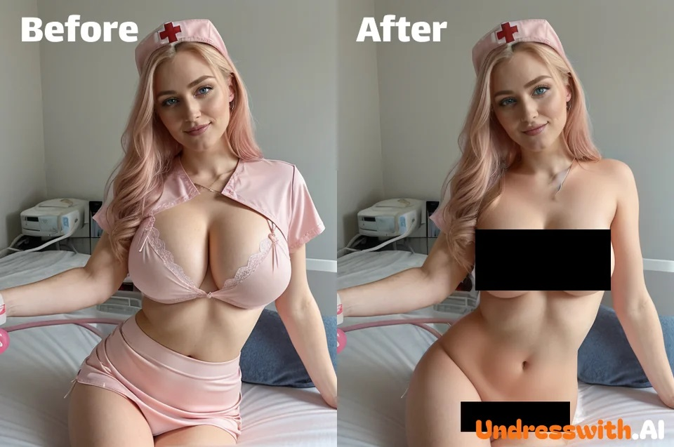

In the present quickly progressing mechanical world, man-made brainpower (simulated intelligence) keeps on rethinking the limits of development and moral quandaries. Among the most dubious improvements lately is the rise of the Disrobe computer based intelligence instrument, a product application intended to mimic the expulsion of dress from pictures. While this innovation has drawn critical consideration, it has likewise raised pivotal moral, legitimate, and cultural worries that request a more profound investigation.

What is the Strip simulated intelligence Device?

The Strip simulated intelligence device is a product program controlled by cutting edge AI and picture handling calculations. It is intended to control computerized photos by taking off dress from people in pictures, making a reenacted "stripped down" appearance. The instrument utilizes brain networks prepared on huge datasets of human life structures and dress examples to accomplish an exceptionally reasonable impact.

This product has acquired reputation for its likely abuse, starting warmed banters in tech networks, among administrators, and inside the overall population. While engineers guarantee it very well may be utilized for genuine purposes, for example, style plan or computerized workmanship, its essential use has frequently drifted into the domain of double-dealing.

How Does the Innovation Function?

The Disrobe man-made intelligence apparatus depends on Generative Antagonistic Organizations (GANs) to create its outcomes. These organizations comprise of two parts: a generator and a discriminator. The generator makes pictures, while the discriminator assesses their validness. Through iterative cycles, the man-made intelligence figures out how to create profoundly reasonable "stripped down" pictures by imitating surfaces, forms, and concealing.

Key stages in the process include:

Picture Information: Clients transfer a computerized photo into the product.

Information Examination: The artificial intelligence dissects the picture, recognizing the subject's posture, shapes, and dress examples.

Reenactment Age: The product creates another picture in view of its preparation information, recreating what it "predicts" to underneath the dress.

Yield Conveyance: The controlled picture is then conveyed to the client, frequently with startlingly sensible outcomes.

This cycle is filled by monstrous datasets and AI procedures, making it both profoundly successful and hazardously vulnerable to abuse.

The Moral Situation Encompassing Disrobe man-made intelligence Apparatuses

While mechanical advancement is many times praised, the Disrobe computer based intelligence instrument addresses a more obscure side of development. Its moral ramifications are significant, addressing issues of protection, assent, and the potential for misuse. Underneath, we inspect the absolute most squeezing concerns.

1. Infringement of Security

The center usefulness of the Strip simulated intelligence device innately abuses a singular's more right than wrong to security. By making controlled pictures without the subject's assent, the product empowers a type of computerized voyeurism that can have wrecking individual and expert ramifications for casualties.

2. Chance of Abuse

The abuse of this device presents huge dangers of double-dealing, especially for ladies and minors. Non-consensual picture control can prompt reputational harm, profound injury, and, surprisingly, lawful ramifications for the culprits.

3. Support of Unsafe Generalizations

Devices like these sustain unsafe cultural standards by commodifying and externalizing the human body. They add to a culture that reduces individual independence and encourages undesirable guidelines.

4. Legitimate Ambiguities

Numerous locales need clear legitimate [undress ai tool](https://shorturl.at/4eZsq) structures to address the particular difficulties presented by computer based intelligence instruments like this one. This lawful ill defined situation confounds endeavors to consider designers and clients responsible for unscrupulous activities.

Expected Applications and Abuses

In spite of the fact that defenders contend that the Disrobe simulated intelligence apparatus has authentic applications, for example, upgrading computer generated reality encounters or helping with creative undertakings, the mind-boggling concern lies in its true capacity for abuse. Underneath, we investigate the two sides.

Authentic Purposes

Style Industry: Architects could utilize the device to imagine clothing examples and plans on models.

Craftsmanship and Amusement: Computerized specialists could utilize it to make creative visuals for projects.

Clinical Preparation: Reproduced life structures could aid instructive settings.

Ill-conceived Utilizations

Non-Consensual Picture Sharing: The device's result can be circulated without the subject's assent, prompting extreme damage.

Cyberbullying: Casualties might confront badgering and public disgracing because of controlled pictures.

Shakedown and Blackmail: Noxious entertainers could utilize the device to force casualties into consistence.

Administrative and Mechanical Reactions

Tending to the difficulties presented by the Disrobe computer based intelligence instrument requires a complex methodology, joining regulative measures, innovative protections, and public mindfulness crusades.

1. Sanctioning Strong Regulations

State run administrations should present extensive regulation that expressly condemns non-consensual picture control. Such regulations ought to force serious punishments on both the designers of these apparatuses and the individuals who use them malignantly.

2. Executing Moral artificial intelligence Norms

Engineers ought with comply to severe moral rules, guaranteeing that their artificial intelligence applications are planned with shields against abuse. This incorporates consolidating assent check situation and watermarking controlled pictures.

3. Teaching General society

Bringing issues to light about the dangers related with artificial intelligence devices is significant. Instructive missions can engage people to perceive and report occurrences of misuse, cultivating a more secure computerized climate.

4. Utilizing computer based intelligence for Good

Strangely, man-made intelligence itself can be a strong partner in fighting abuse. Instruments can be created to identify and obstruct non-consensual picture control, giving an extra layer of insurance.

Instructions to Safeguard Yourself On the web

During a time where computerized control is turning out to be progressively modern, safeguarding yourself online is a higher priority than any time in recent memory. Here are a few viable tips to protect your security:

Limit Individual Picture Sharing: Be mindful about sharing pictures on open stages, particularly those that uncover individual subtleties.

Utilize Secure Stages: Select stages with hearty protection settings and encryption.

Report Misuse Speedily: Assuming you suspect your pictures have been controlled, report the episode to specialists and applicable stages right away.

Remain Informed: Stay up with the latest with mechanical turns of events and figure out how to perceive possible dangers.

End: The Way ahead

The Strip computer based intelligence instrument fills in as an unmistakable sign of the twofold edged nature of mechanical advancement. While simulated intelligence can possibly reform ventures and further develop lives, it additionally presents critical dangers when employed flippantly. As a general public, we should figure out some kind of harmony among development and moral obligation, guaranteeing that innovative headways are utilized to inspire instead of mischief.

By cultivating joint effort among engineers, legislators, and people in general, we can make a computerized future that focuses on protection, assent, and regard for all people. The discussion encompassing instruments like these is nowhere near finished, however with proactive measures, we can make ready for a more secure and more fair mechanical scene.